

American International University-Bangladesh (AIUB)  
**Department of Computer Science  
Faculty of Science &Technology (FST)  
Fall 22 23**

**<ON DEMAND SECURITY SYSTEM>**

Software Requirement Engineering

Sec: **B**

Project submitted

By

*NAME ID*

*MD. JAHID HASSAN 19-40264-1*

*MD. ALI AHSAN 19-40254-1*

*MD. FORHAD KANON 19-41006-2*

*MD. MONJURUL ISLAM ARMAN 19-39482-1*

**Checked By Industry Personnel**

Name:

Designation:

Company:

Sign:

Date:

Table of Contents

1. **PROBLEM DOMAIN** …………………………………………………...….............. 3
   1. Background to the Problem……………………………………………………….3
   2. Solution to the Problem…………………………………………………………3-4
2. **SOLUTION DESPRIPTION** ………………………………………………………...4
   1. System feature …………………………………………………………………….4

2.1.1 Each user feature…………………………………………………….4

2.1.2 Features for all user………………………………………………….4

2.1.2 Features for system admin…………………………………………..4

2.1.4 Features for customer………………………………………………..5

2.1.5 Features for employee……………………………………………….5

2.1.6 Functional requirement………………………………………………5

2.1.7 Quality attribute requirement………………………………………..6

2.1.8 User interface design…………………………………………….6-11

* 1. UML Diagram ……………………………………………………………………11

2.2.1 Use case diagram……………………………………………….11-12

2.2.2 Activity diagram………………………………………………. .12-14

2.2.3 Class diagram…………………………………………………… ..14

1. **Social Impact** …………………………………………………………………............15
2. **Development plan with Project Schedule**………………………………………15-16
3. **Marketing Plan**……………………………………………………………………….17
4. **Cost and profit Analysis**………………………………………………………….......18

**6.**1 Requirement cost…………………………………………………18-19

6.2 Project management cost…………………………………………18-19

6.3 Design cost…………………………………………………………..19

6.4 Development cost……………………………………………………19

6.5 Testing cost…………………………………………………………..19

6.7 Maintenance cost…………………………………………………19-20

1. **Reference** ………...……………………………………………….………………..20
2. **PROBLEM DOMAIN**
   1. **Background to the Problem**

* In our daily life sometimes, we need to go outside at late night for emergency work or when we visit any new place for working purpose or visiting, we feel the need of a guide who can help us to know the place or give us security. A female student or worker also wants security when they need to travel at night. Now-a-days it becomes so hard for working parents to take care of their children specially on the daytime. During Covid-19 pandemic we feel the need of delivery small things like official paper, home-made food to relative’s house and so many things. By giving security guard who will ensure safety, baby-sitter for alone children or a delivery man who will deliver small domestic products from one place to another can solve those mentioned problem.

A school, college, university, company or industry needs the security guard for their safety purpose. We provide the well trained and trusted security guard or security system for them. For example, CC camera, fingerprint door lock etc. To keep it those necessity in our mind we want develop this project that will provide all those services whenever customers request it for.

* The main cause of this problem we could not trusted any person in a single day. That’s why we find the honest and experienced people. We provide them the experienced and trusted people also. They did not worry about their security. We provide the best security for them.

We consider this problem just because to insured the safety of the people. And this project will create the opportunity for both customer and employee. The students those need part time job, jobless who need job, female students, all of them can earn money by giving those services to customer. And the general people who are the main customer will get service like security, baby care at daytime just by sending request using this system. Overall, it will create job sector for jobless and service sector for general people.

* 1. **Solution to the Problem**
* Our Project is concern about to help common people with security especially women and children security. According to report it says daily 13 Females are being raped. The unregistered number is far more. The female Harassment in public places even outside of the school college are very alarming. Eve teasing rate is also high in our country. Our software and the ecosystem will solve this problem. The need for baby siting is increasing rapidly. As women are now working alongside man, they need a person to watch their babies. So, a platform of babysitters will help to fulfil the requirement of them.

Women are half of our population. We cannot neglect them to devolvement of our nation. They are more vulnerable than man. If, women are harassed this way they will lose confident to do work and achieve something. As result families will discourage for women education and work. As result we will lose a capable force from our country. For our system women will feel safe to travel at night be themselves everywhere. As result the economy of our country will increase.

* We want to create a system which will provide on demand security services. Under this system there will be enough employees in both gender who will be ready for giving services whenever customers will request.

As employees, there will work students, recently graduates who are searching for job and any candidate who can full-fill the job requirements. So, this system will target our job market by giving jobless’ work opportunity.

* The main audience would be general people. They will be able to request for services like security, baby-sitting, delivery home made products through this system whenever they are on need. We belief that the existing software is the solutions for the customer and employee also.

1. **SOLUTION DESCRIPTION**
   1. **System Features**

**2.1.1 Our System will used by a number of people for each user. For each user there are some features**-

* **System Admin:** System admin can control the whole system. He can manage the customer and employee.
* **Customer:** Customer can find the job in the website as he wants. He can hire employee from the system.
* **Employee:** Employee can find the job from website as he wants. Part time and full time all job is available in the system.

**2.1.2 Features for all users:**

* **Registration:** Customer and employee both of them can be registration in the system.
* **Login:** Customer and employee both of them can be registration in the system.

**2.1.3 Features for system admin:**

1. Verify user's profile
2. Block or approve users
3. Manage customer and employee access requests
4. Check all the documents employees and customers
5. Analyze user data
6. Update application

**2.1.4 Features for Customer:**

1. View or edit personal profile
2. Search employee
3. Check all different categories employees
4. Hire service
5. Choose time and date while request for a service
6. See notification
7. Make payment System
8. Review service and provide feedback
9. Report problem
10. Contact support

**2.1.5 Features for Employee:**

1. View or edit profile
2. View types of job
3. Search job
4. Check notification from system
5. View payment through system
6. Review Customer
7. Report problem
8. Contact support

**2.1.6 Functional requirement:** A Functional Requirement (FR) is a description of the service that the software must offer. Our system: On Demand Security System:

* + Can store employee and customer information
  + Can observe employee and customer status
  + Can check availability for job
  + Can generate list for the customer from the system
  + Can calculate total customer and employee.
  + Can cancel the request from employee or customer.
  + Can reschedule any job.
  + can check employee and customer identity.
  + can check employee and customer ID Card Number.

**2.1.7 Quality attribute or non-functional requirement:**

* **Security:** The software will build for protect the employee. The software typically works in conjunction with Internet usage to control or limit the amount of information made available to third parties. The software can apply encryption or filtering of various kinds.
* **User friendly:** The software made too much user friendly for customer and employee both. They can easy use it.
* **Reliability:** It is an important non-functional requirement for most software. Itis usually defined as the probability that our software will operate without failure for a specified number of uses (transactions) or for a specified period of time
* **Availability:** The software is available in website server and play store for the mobile user.
* **Portability:** The software is lite wait and available in the website and google play store.

**2.1.8 User Interface and Experience (UI/UX):**

**Login Page:**

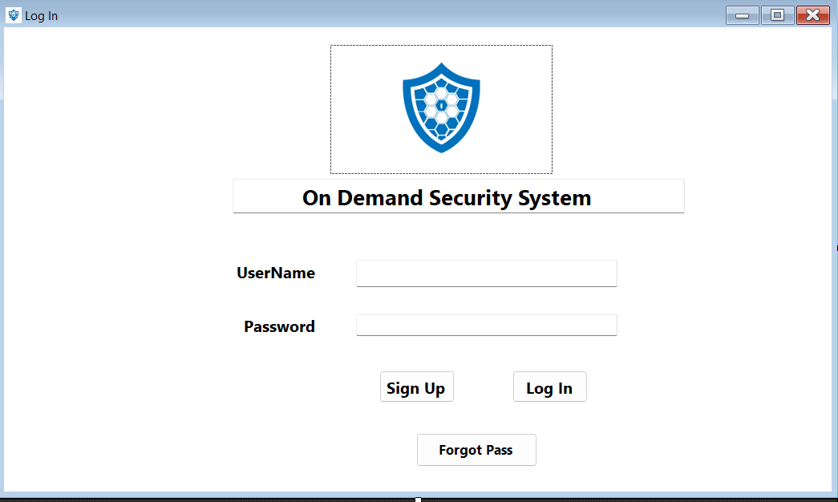

**Registration:** 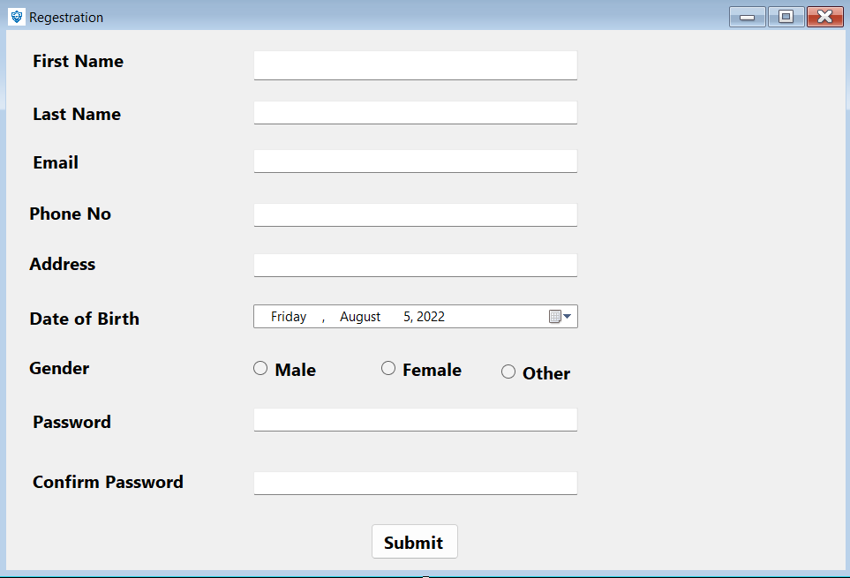

**Verification:**

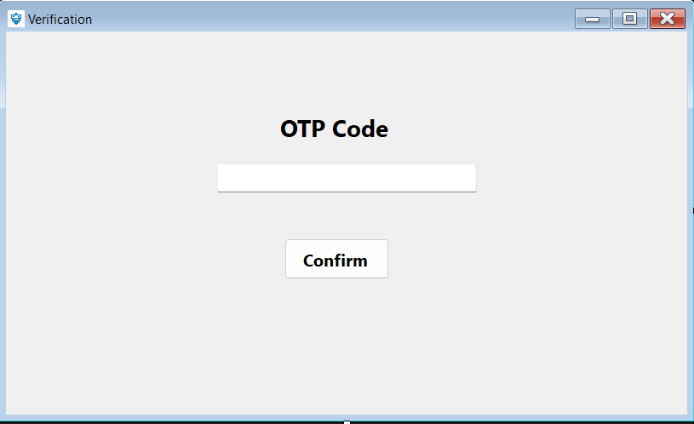

**Signup:**

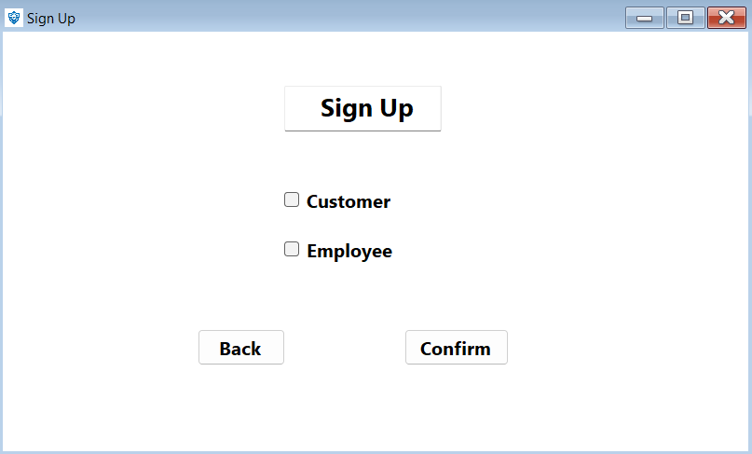

**Home page:**

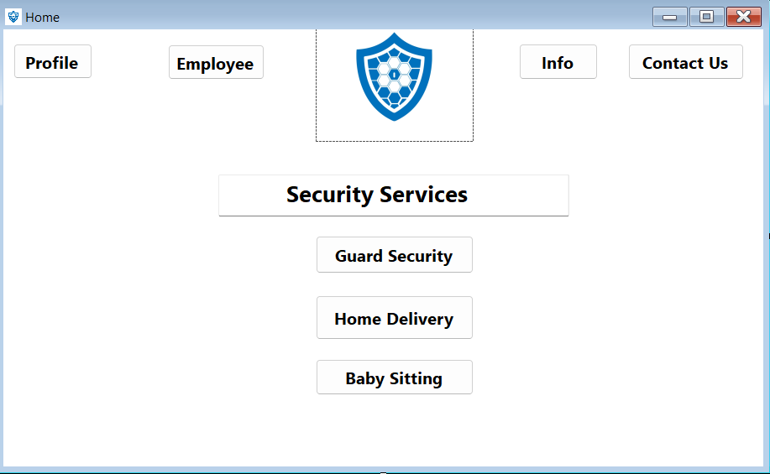

**Profile:**

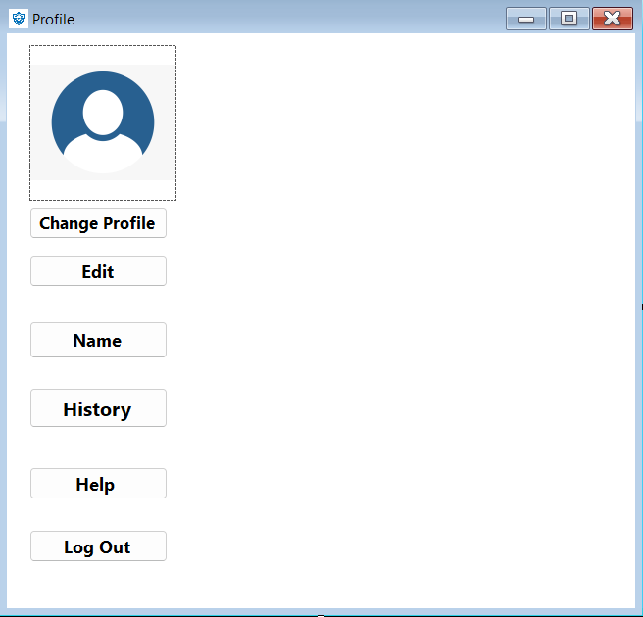

**Employee:**

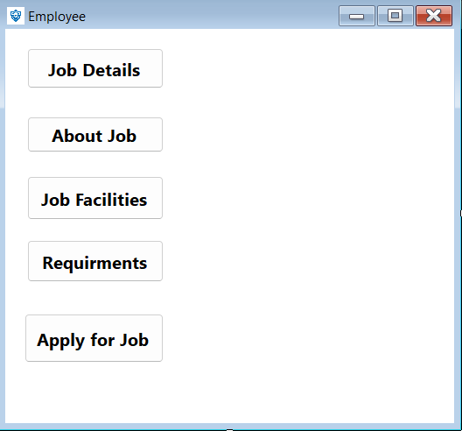

**Apply for job:**

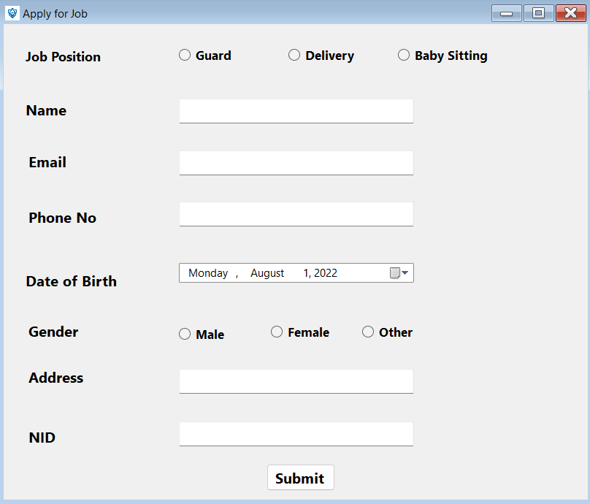

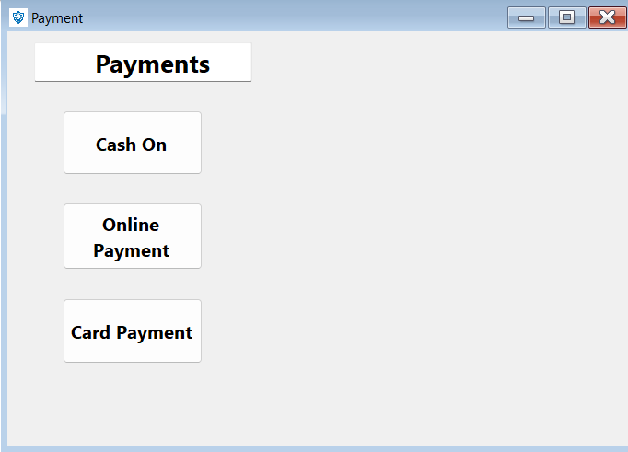**Payment:**

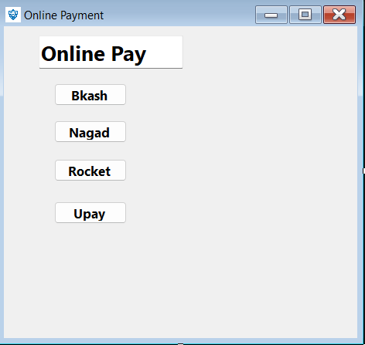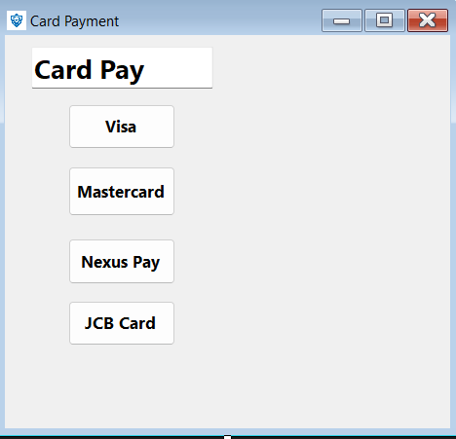

* 1. **UML Diagrams**

**USE CASE DIAGRAM**

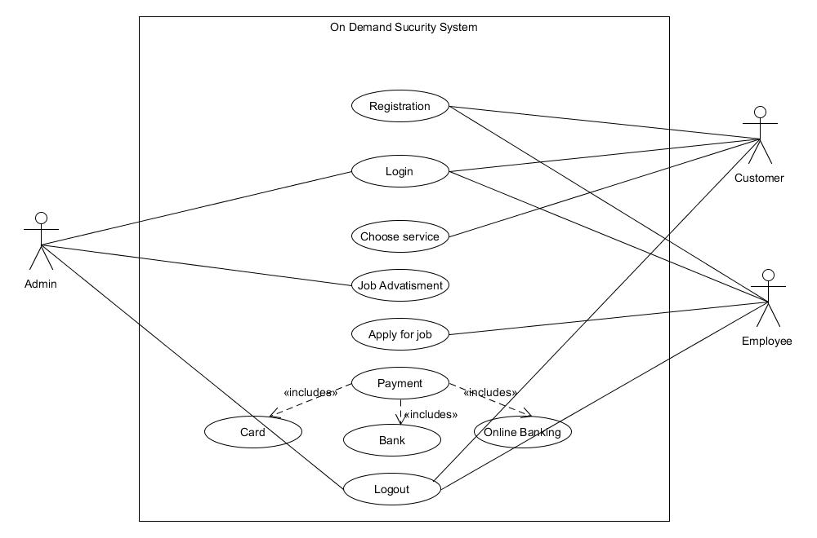

**Fig-2.2.1: use case diagram**

Customer and employee can registration in the system. Admin, customer and employee can loin in the system. Customer can choose the service. Employee can also choose and find the service. Part time and full time both the job in this website. Employee can apply for job. Customer can request for job circular through this website. Customer can pay through the website. Employee can get the payment from the website.

**ACTIVITY DIAGRAM**

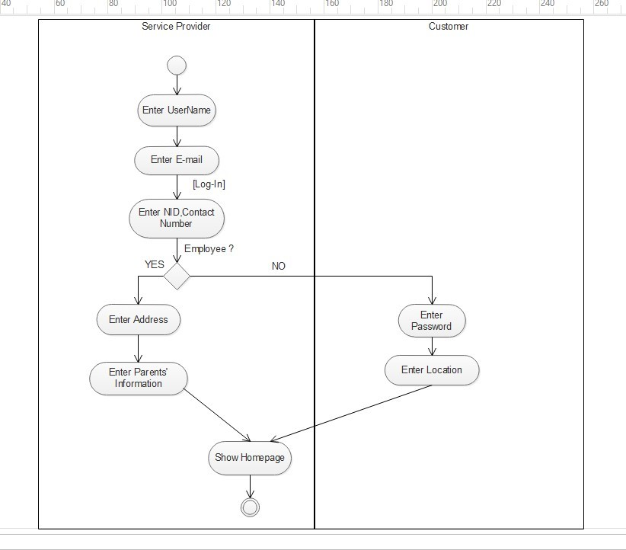

**Fig-2.2.2: ACTIVITY DIAGRAM**

Employee can login website by user name and password. If already account then advice to them login. If not then take them to the registration page. After successfully login show the home page. And search the service as he want.

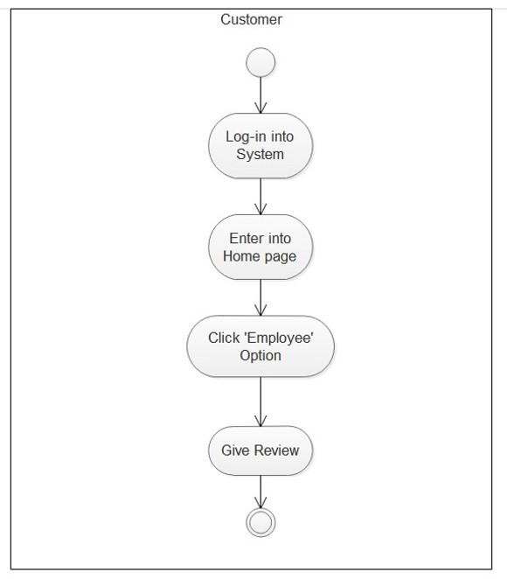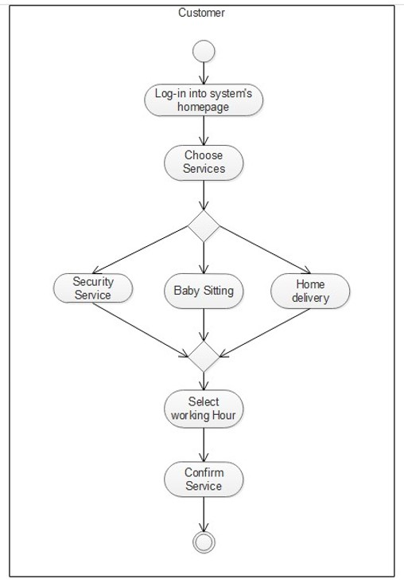

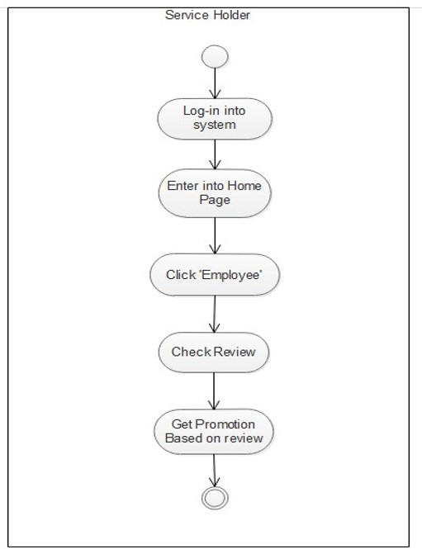

Customer can login website by user name and password. If already account then advice to them login. If not then take them to the registration page. After successfully login show the home page. And search the job as he wants. Part time and full time all jobs are available in this website.

**ClASS DIAGRAM**

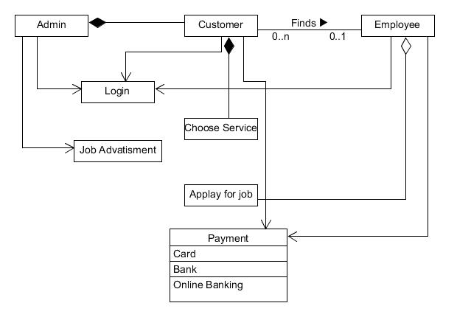

**Fig-2.2.3: Class diagram**

Customer and employee can registration in the system. Admin, customer and employee can loin in the system. Customer can choose the service. Employee can also choose and find the service. Part time and full time both the job in this website. Employee can apply for job. Customer can request for job circular through this website. Customer can pay through the website. Employee can get the payment from the website.

1. **Social Impact**

We hope that our “On demand security system” project helps the society and people will be benefitted from it. It helps the people hassle free and find out the best solution for them. A person who needs a job and who needs a service both of them are benefitted. The system can be reduced unemployment and people who needs the service from them, both of them are can be using it. A company need not waste of time for hired their security. They can easy use this website and take the well train security. A female student or worker also wants security when they need to travel at night. Now-a-days it becomes so hard for working parents to take care of their children specially on the daytime. During Covid-19 pandemic we feel the need of delivery small things like official paper, home-made food to relative’s house and so many things. By giving security guard who will ensure safety, baby-sitter for alone children or a delivery man who will deliver small domestic products from one place to another can solve those mentioned problem. These are the social impact in our project.

1. **Development Plan with Project Schedule**

* Since the model chosen for completion of the project is agile method, by taking effort estimation in account it was found that 130 working days is required to complete the project. On the basis of Rational Unified Process, the time phase for each task can be divided as follows:

|  |  |  |
| --- | --- | --- |
| **Task of phase** | **Days** |  |
| Requirements Elicitation | 21 |  |
| Project Planning | 18 |  |
| Requirements Analysis | 14 |  |
| System Design | 28 |  |
|  |  |  |
| Implementation & Unit Test | 37 |  |
| System Integration & System Testing | 21  15 |  |

**Note:** Every engineer works 8 hours a day, 6 days a week. The overall length of the project is 154 working days, (excluding national holidays).

**The gantt Chart of the work flow is shown below:**

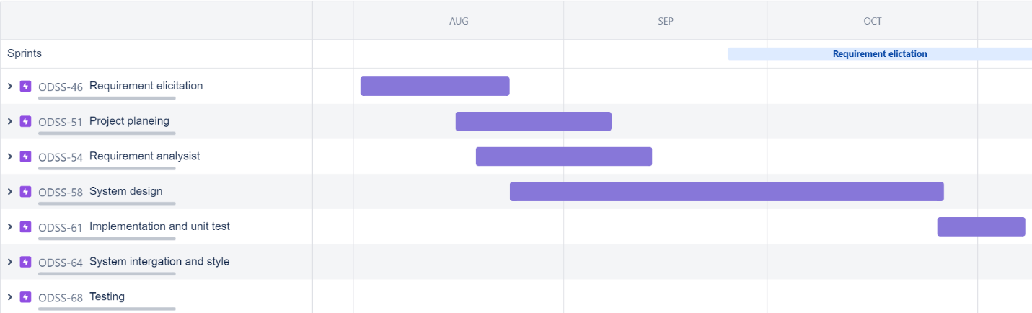

Fig-4.1: Roadmap

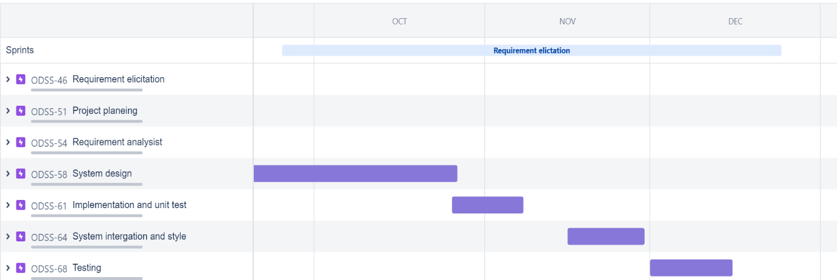

Fig-4.2: Roadmap

After analysis the data BA’s update all data in SRS document. And all the data and work divided into the group. Project planning group manage all the team and group work. Requirement analysis group identify all user group and collect data from the stakeholder and users.. Design engineer will design the system feature and the database. Codding team will develop the code and implement the features in the website. Testing team will test the code and all type of data and database connection.

1. **Marketing Plan**

* **Social media to engage audiences:** We need to how users or society people will typically interact with each social media platform, which will make a considerable impact on the results app publicity. Here are some essential popular social media platforms.
* **Facebook:** Facebook is the world's largest social network, with more than 1 billion users worldwide. It is used to publicity of a software and give idea how people can be benefited by using on demand security system app. Facebook ad is the best marketing strategy for advertise any software. So, it can be a best option to advertise in Facebook.
* **Twitter:** Twitter is another popular social media platform. It connects us to the most valuable and influential people, when they are most receptive. Twitter has obviously been used to raise awareness of security. So, we can easily introduce our software in this social platform.
* **Target audience and the persona:** For an effective marketing plan, we need to identify and understand the target audience is the first step. So we need to build a market strategy, we must identify the target audience. In general, targeting the right audience ensures our marketing efforts perform better and lead to higher sales or conversions. The first step toward identifying these prospects is putting together an ideal customer profile, sometimes called a buyer persona. Target audience analysis allows us to make personalized content for your customers that complies with their user persona.
* **Build marketing strategy**: It is a way that addresses the main points and provides the audience with useful solutions.
* **Efficient budget use:** A marketing budget outlines all the money a business intends to spend on marketing-related projects over the quarter or year. Marketing budgets can include expenses such as paid advertising, sponsored web content, new marketing staff, a registered blog domain, and marketing automation software.
* **User short- and long-term marketing goals:** Short-term goals are the ones that we want to accomplish in 6 months or less. These goals generally make it from start to finish in a matter of days, weeks, or months. We can more easily judge the success of your short-term marketing objectives with things like email reports or tracking results through tracked links. Long term marketing goals should include a strategy for hooking customers for life and building a long-term customer base. The best and most brilliant long term marketing goals incorporate a strategy to encourage lifelong customers to pass their brand loyalty on to their children.

1. **Cost and Profit Analysis**

**Estimation Cost:**

Estimation as per the basic COCOMO'81the software is semi-detached type. The estimation formula for Embedded software:

Coefficient, C= 3.0

Complexity, P= 1.12

Dependent constraint T=0.35

Assume that the size of an organic type software product has been estimated to be 5,000 lines of

source code.

Source line of code= 5,000

Effort = 3.0*(5000/1000) ^1.12

= ~ 18 p/m

Development Time = 2.50 * (18) ^0.35

= 7 months

Project development time = 7 months

Estimated Budget:

Working days = 6 days in a week

Working hours per day = 8 hours

Working hours in 7 month=(7*48*24)= 8064 hours

* 1. **Requirement Cost:**

Business analysis salary per month= 150,000 per/month

Salary per day=(150000/24)=~6250 TK

|  |  |
| --- | --- |
| **Work Type** | **Cost (TK)** |
| Collect data from stakeholder (6 Days) | 6*6800=37500 |
| Communicate with user group(8Days) | 8*6800=50000 |
| Analysist functional requirement(4Days) | 4*6800=25000 |
| Analysist non-functional requirement(3Days) | 3*6800=18750 |
|  | **Total cost=131250 Tk** |

* 1. **Project Manager Cost:**

Project manager salary per month= 110000 Tk

Salary per day=(110000/24)=~4500 TK

|  |  |
| --- | --- |
| **Work Type** | **Cost (TK)** |
| Project planning (12 Days) | 12*4500=5400 |
| Management Team (2 Days) | 2*4500=9000 |
| Work distribution (4 Days) | 4*4500=18000 |
| Unfamiliar method identify (14 Days) | 14*4500=63000 |
|  | **Total=144000** |

* 1. **Design Cost:**

Designer salary=50000 Tk per month

Salary per day=(50000/24)=~2000 TK

|  |  |
| --- | --- |
| **Work Type** | **Cost (TK)** |
| Whole project design(8Days) | 8*2000=16000 |
| Website Design(8Days) | 8*2000=16000 |
| Mobile App design(6Days) | 6*2000=12000 |
| Database design(6Days) | 6*2000=12000 |
|  | **Total cost= 56000** |

* 1. **Development Cost:**

Developer salary=80000 tk per month

Salary per day=(80000/24)=~3300 TK

|  |  |
| --- | --- |
| **Work Type** | **Cost (TK)** |
| System Integration & System (21Days) | 21*3300=69300 |
| Unit Testing(12 Days) | 12*3300=39600 |
| Coding(25Days) | 25*3300=82500 |
|  | Total=191400 |

* 1. **Testing Cost:**

Tester salary =40000 per/month

Salary per day=(40000/24)=~1600 TK

Total cost=15*1600= 24000 tk

* 1. **Maintenance Cost:**

Monthly 10 Hours (7 months and per hour salary 1000) Cost=10 x 7 x 1000=70,000 tk

**Total Cost:**

|  |  |
| --- | --- |
| Requirement Cost | 131250 |
| Project Manager Cost | 144000 |
| Design Cost | 56000 |
| Development Cost | 191400 |
| Testing Cost | 24000 |
| Maintenance Cost | 70000 |
| Website hosting Cost | 40000 |
| Marketing cost | 120000 |
| Training Cost | 130000 |
| Office cost | 150000 |
| Utilities Cost | 60000 |
| **Total** | **=986650** |

**Estimation Profit:**

Those who will use our service they have to pay some amount of money. An additional 8% of the employee's salary will be charged to customer who use our service. And additional 5% of the employee's salary will be charged to employee. For example, a employee’s salary is 20000 tk. Then profit from customer=20000*8%=1600tk and profit from employee= 20000*5%= 1000tk. Hear, total profit=1600+1000=2600 from 1 employee per month. If 100 employee work in 1 month then profit= 2600*100= 260000. After 4 month we will be benefited (4*260000=1040000-986650)=53350. After that our profit 8%+5%=13% every month.

1. **Reference**

* Wiegers, K., & Beatty, J. (2013). *Software requirements*. Pearson Education.
* http://www.cs.ccsu.edu/~stan/classes/CS530/notes14/04-Requirements.html
* [www.google.com](http://www.google.com)
* https://www.atlassian.com/software/jira
* Software Engineering course (CSC3121) AIUB.